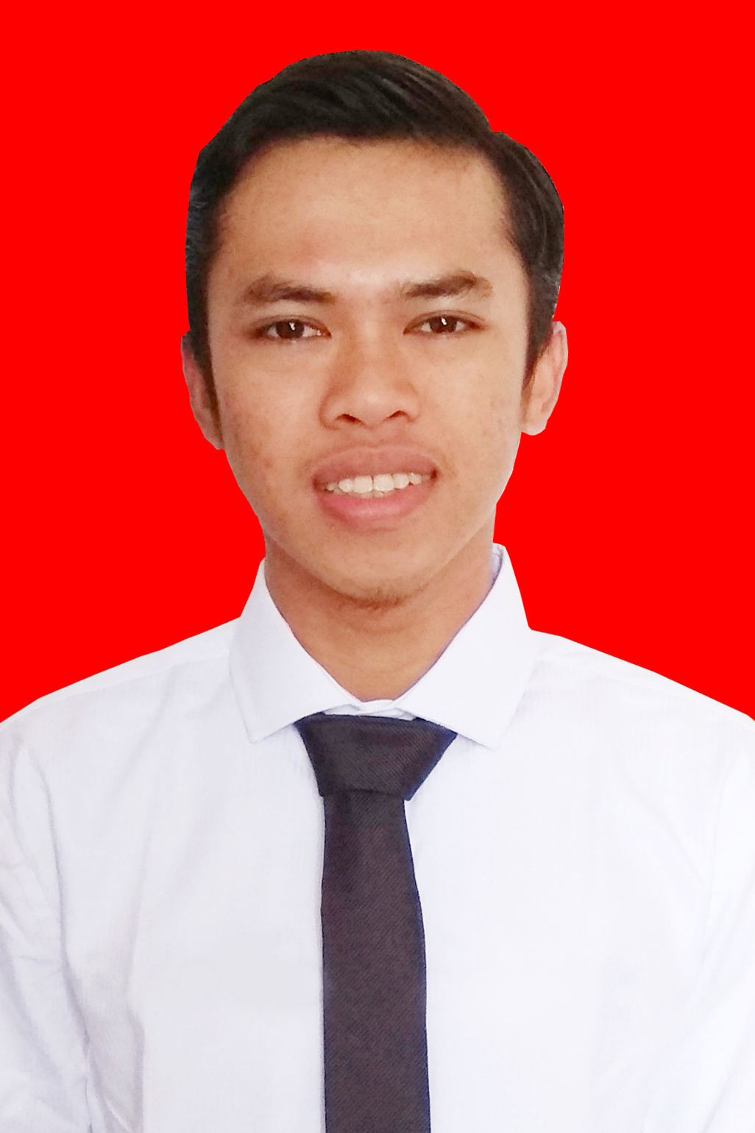
PHOTO

ADE SULAEMAN
Summary
Graduated from Esa Unggul University, with almost 2 years of experience as a Software
Engineer and other project, I am looking for ways I can contribute my skills towards technology
advancement in software industry internationally.
As an IT .Net for PT Adicipta Inovasi Teknologi dan Full stack developer for project Kemdikbud RI. Do a quality assurance of the program, create a report and user manual, perform data migration, designing database structure, provide training to user and supporting (UAT and Go-live).

Education
- Bachelor Degree – Information Technology, Esa Unggul University, Jakarta (September 2014 – Maret 2018). GPA 7.73 .

Work Experience
- PT. Adicipta Inovasi Teknologi (April 2018 – present)
Production Support Department
- Maintanance System
- Support System Team
- Fixing Bugs
- Developtment Change Request
- Data Correction
- PT. Probiz Prima Integrasi (April 2017 – April 2018)
Web Developer
- Developtment
-Design
-Implementastion
-Testing
-Documentation
Projects
- CONFINS (April 2018 - Present)
.Net Developer
Maintanace system in Production and UAT for more than five companies Multi Finance.

- SISTEM REGISTRASI NASIONAL MUSEUM (April 2019 – Present)
Full Stack Developer
Building, development and presentation system for register museum in Indonesia .

Key Skills and Expertise
- C#, ASP.NET, C++, PHP (Codeigniter, Laravel), Javascript, JQuery, CSS (Bootstrap), HTML, JAVA, Linux, Mobile Application
- SQL Server, MySQL
- OOP

Certification
- Junior Programmer (Badan Sertifikasi Profesi Kemkominfo RI)
- MoonsoonSIM Bussiness (ERP) - Moonsoon Academy
- IT ESSENTIALS: PC HARDWARE AND SOFTWARE - CICCO NETWORKING ACADEMY
- CCNA Routing and Switching: Introduce to Networks - CICCO NETWORKING ACADEMY
- CCNA Routing and Switching: Routing and Switching Essentials - CICCO NETWORKING ACADEMY

Languages

1) BAHASA INDONESIA
2) ENGLISH TOELF - (PAMU ESA UNGGUL UNIVERSITY) SCORE : 474

